Application development with Microservice Architecture in Enterprise Java

A Spring Boot Case Study

Academic Year 2016-2017

Supervisor(s): Patrick De Ryck

Co-supervisor(s): Jeroen Sterken

Lennart COCKX

Guangming LUO

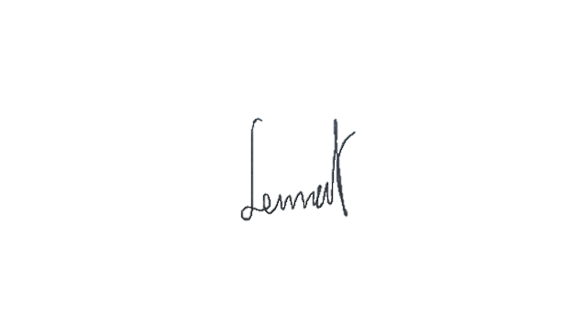



Master Thesis submitted to obtain the degree of Master of Science in Engineering Technology: *Master of Electronics and ICT Engineering Technology*

© Copyright KU Leuven

Without written permission of the supervisor(s) and the author(s) it is forbidden to reproduce or adapt in any form or by any means any part of this publication. Requests for obtaining the right to reproduce or utilise parts of this publication should be addressed to KU Leuven, Technology Campus Groep T Leuven, Andreas Vesaliusstraat 13, B-3000 Leuven, +32 16 30 10 30 or via email fet.groept@kuleuven.be.

A written permission of the supervisor(s) is also required to use the methods, products, schematics and programs described in this work for industrial or commercial use, and for submitting this publication in scientific contests.

**Faculty of engineering technology**

CAMPUS GROuP T LEUVEN

Andreas Vesaliusstraat 13

3000 LEUVEN, Belgium

tel. + 32 16 30 10 30

fet.groupt @kuleuven.be

www.fet.kuleuven.be